

Target State Analysis

Matchmaking

# Overview

## Introduction

Matchmaking is a new service of the MassIdea platform. It connects people, groups and projects with similar attributes. This helps to keep the whole MassIdea network together and reduces redundancy in the semantic structure.

The target of the matchmaking component is to build graphs of connected people, which indicate hot spots in those networks. Therefore, such graphs are a perfect base for finding important or popular people within groups and projects. Additionally, the component has some benefits for users. It suggests appropriate groups and projects when viewing content and helps to get in touch with other people of similar interest.

Results were created in a design thinking session on Friday November 20, 2012.

## Ideas

After a 30 minute brainstorming session the following map of keywords was created:

*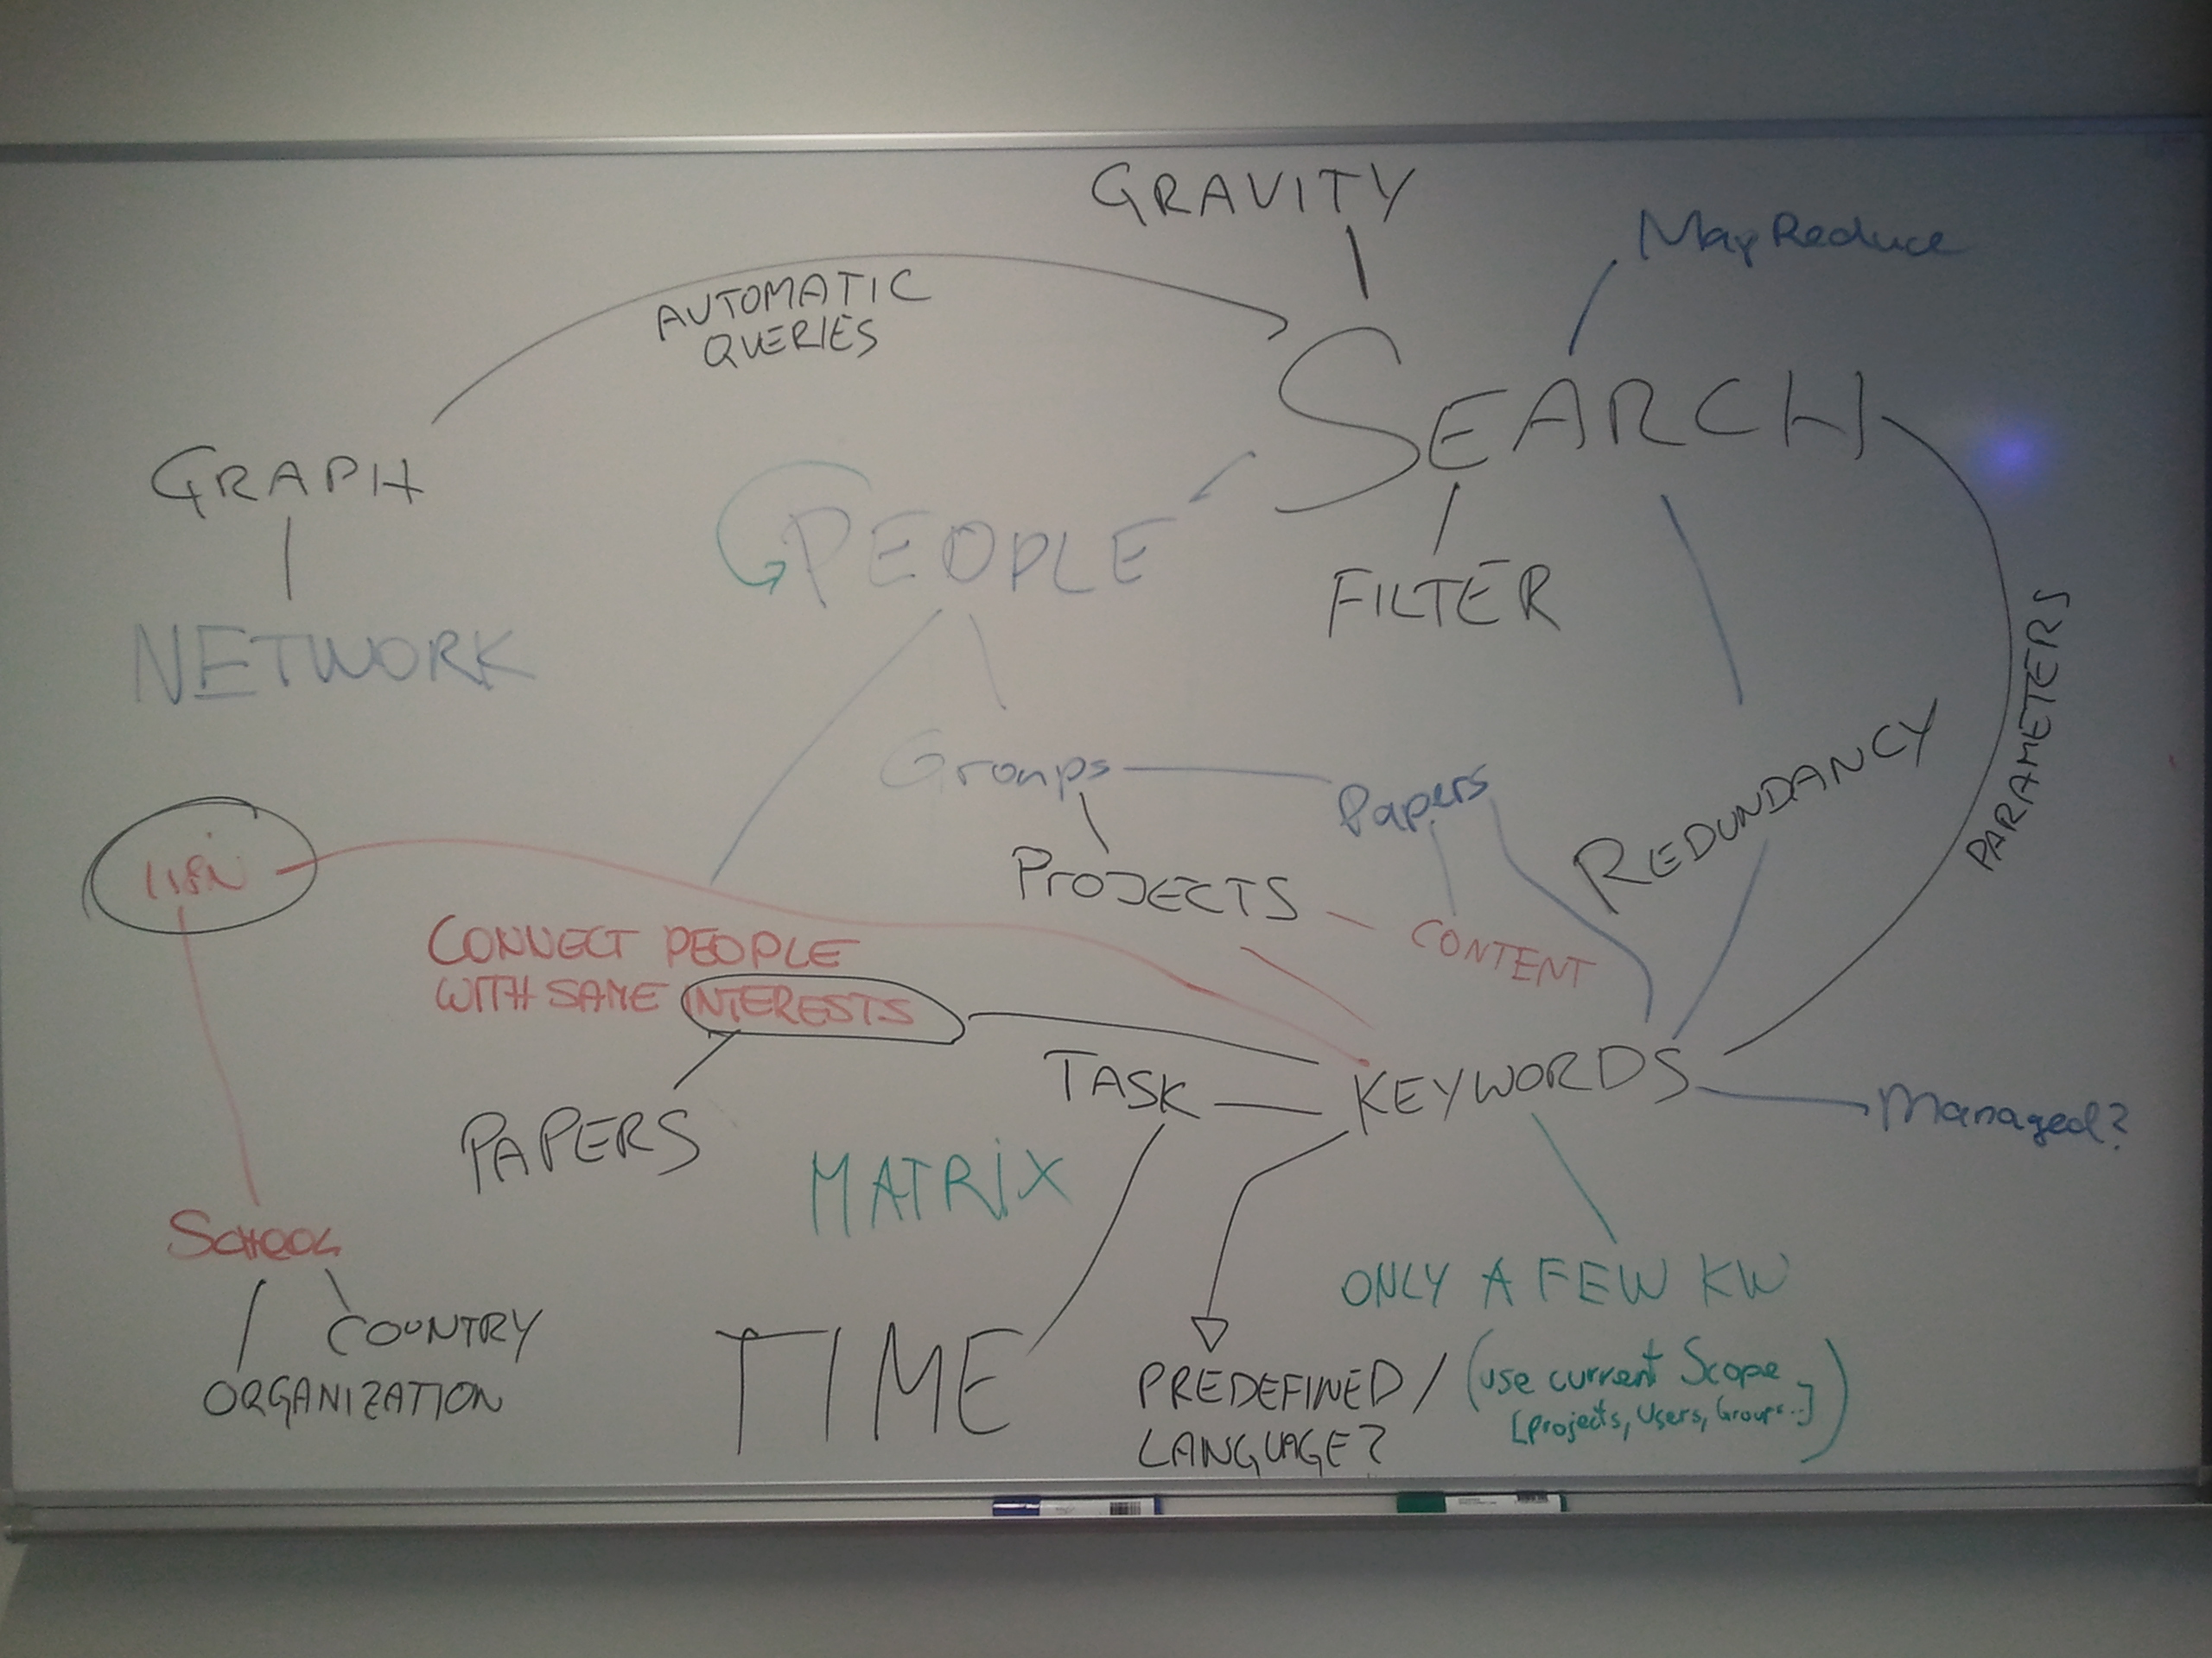  
Figure 1: Terms and ideas connected to the matchmaking functionality.*

Two very important components could be determined:

* **Search**: Matchmaking is based on a search component and fires automated search queries. The results of such queries might be visualized in graphs or lists next to the main content.
* **Keywords**: The search functionality, on the other hand, depends on keywords, which help to classify content. Problems with keywords are synonyms and internationalization, as this complicates finding a match.

# Results

## Targets and dissociation

At the beginning, the matchmaking component will target the educational sector – especially in the language teaching and training field. Therefore, European languages and also types of educational institutions are offered for auto-completion.

Once the system has been tested and approved by language teachers, it will be extended for other fields in the educational sector. Further improvements and enhancements are subject to future discussions.

## Structure

Based on this, the following fields of application were found for the matchmaking component:

* **Automatic suggestions**
* Profile bootstrapping
* Finding collaborators for projects
* Organize students in a virtual class
* Organize tasks for such classes
* Match papers of graduates
* Build graphs of publications
* Visualize these graphs
* Create automatic profiles
* Extend profiles with appropriate information

For reasons of simplification, only automatic suggestions will be treated in this document.

## Keywords

To specify the final functional principle, keywords need to be redefined. In order to offer easy access to basic attributes, they are split up into the following components:

* **Jobs / Industry**: A predefined list of jobs from the educational sector, which can be extended in future. This field is mandatory.
* **Attributes**: The user chooses from a list of 20 attributes, which depends on the selected job. It is possible to select more than one attribute at the same time. This field is mandatory.
* **Location**: The location of origin. This is mandatory for users, groups and projects.
* **Tasks**: Free text, which explains the main purpose of the content. This is only necessary for projects and groups.
* **Timespan / Deadline**: This is only necessary for projects. A date range which helps the matchmaking component to narrow down results.

These “keywords” are assigned to content (articles/posts), users, groups and projects:

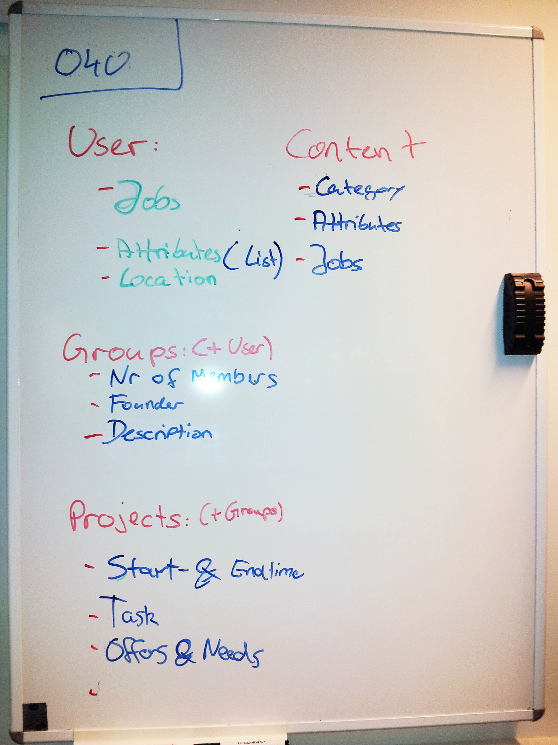  
*Figure 2: Components of keywords*.

# Use Case

The result of the whole workshop was the following Use case on the white board. This use case describes a typical way of communication on the Massidea platform between language teachers called “Ms Gaisch” and “Mr Curties”:

